**TASK 1  
Interconnect Robots**

**Solution:**

In order to move from wired setup to wireless setup in context of robotics manufacturer, there is a requirement to ensure the maintenance of safety-critical functions and real-time critical communication during the incorporation of benefits of wireless technology.

Following is some information related to the transition concept layer by layer:

1. Physical Layer:

In case of wired setup, there is a use of ethernet cables for ensuring high-speed and smooth communication.

In case of wireless setup, 5G technology or Wi-Fi 6 is used for ensuring low latency, high er bandwidth and real-time transmission of data.

1. Data Link Layer (DLL):

In case of wired setup, ethernet is used for data link layer protocols including Profinet or Ethernet/IP for the purpose of ensuring reliable transmission of data.

In case of wireless setup, cellular-based protocols or IEEE 802.11ax including NB-IoT or LTE-M is used for wireless data link layer protocols. The use of methods including TSN allows the maintenance of real-time capabilities over wireless.

1. Medium Access Control (MAC) Layer:

In case of wired setup, CSMA/CD is used for ensuring medium access control.

In case of wireless setup, the implementation of modified TDMA’s version as well as hybrid technique with a combination of TDMA with career sensing methods with suitability for wireless conditions is used. This would allow the efficient access to wireless medium and allow maintenance of real-time requirements.

1. Network Layer:

In case of wired setup, TCP/IP, which is an IP-based protocol is used for communication at network layer.

In case of wireless setup, IP-based protocols are used for ensuring seamless integration with previous infrastructure of network.

1. Transport Layer:

In case of wired setup, the use of protocols like UDP or TCP enhances the reliability and best delivery of data.

In case of wireless setup, the protocols like UDP and TCP are optimized for wireless networks in order to account for latency or packet loss.

1. Application Layer:

In case of wired setup, the protocols are set in accordance to application, for human interaction as well as robot control.

In case of wireless setup, there is a continuity in use of application-specific protocols. However, these protocols are adapted in accordance to wireless communication, with consideration of factors including latency or packet loss.

In order to learn about the detail of protocol design, we can put emphasis on MAC layer and propose Message Sequence Chart and Finite State Machine for wireless setup:

MAC Layer Protocol Design:

Finite State Machine (FSM):

States: Idle, Transmitting, Receiving

Events:

- Transmit_Request

- Receive_Request

- Transmission_Success

- Transmission_Failure

- Reception_Success

- Reception_Failure

Transitions:

1. Idle -> Transmitting (on Transmit_Request)

2. Transmitting -> Idle (on Transmission_Success or Transmission_Failure)

3. Idle -> Receiving (on Receive_Request)

4. Receiving -> Idle (on Reception_Success or Reception_Failure)

```

Message Sequence Chart (MSC):

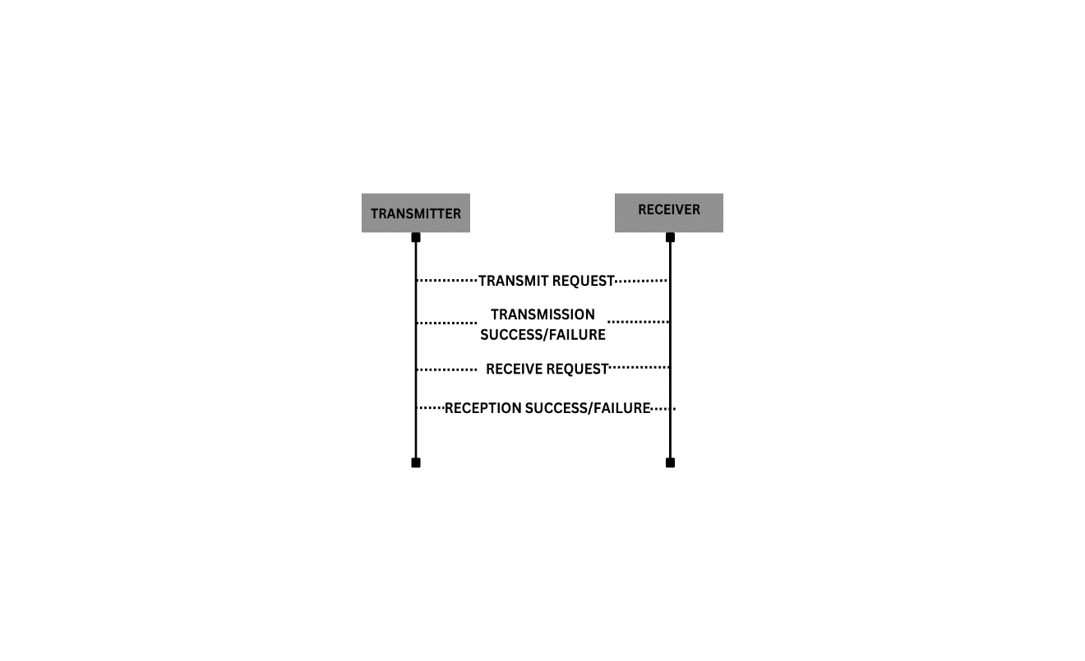

This FSM and MSC illustrate the transitions and message exchanges between the transmitter and receiver in the MAC layer protocol. It highlights the challenges of wireless communication such as transmission and reception failures and how they are addressed in the protocol design.